Mick Germaine Cup 2016

This year’s Mick Germaine Cup competition for teams of four juniors from schools or clubs took place recently in the Ierne Sports and Social Club – home to the Elm Mount Chess Club.

A record number of teams (25) took part in the event. There were seven teams from Blanchardstown, four from Malahide, and three each from Rathmines and Ballinasloe. Two teams took part from Manorhamilton with one each from Elm Mount, Gorey and St. Benildus. Three school teams competed in the event, two from the Glasnevin Educate Together National School and St. Catherines (both Dublin).

The Cup was won by the Malahide Militants with an unbeaten score of 21.5/24 involving 5 wins and one draw over the six rounds of the competition. St Benildus finished in the runners up slot on tie break from the Rathmines Knights with the Rathmines Kings finishing in 4th place.

The final standings are set out below. Pictured are some of the winning Malahide players with Coach Tom O’ Sullivan. Front row from left Adam Gardiner, William Hackett and Finn Ellingboe (team captain with the cup), Back row, Issac Flynn and James Kavanagh. William, Finn and James were on the winning Malahide team.

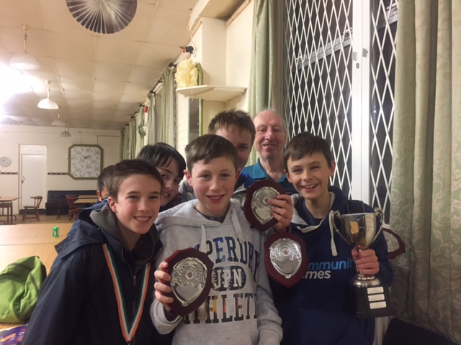

 | Mick Germaine Cup 2016 Final Standings
 | Team | Rd 1 | Rd 2 | Rd 3 | Rd 4 | Rd 5 | Rd 6 | Totals
1 | Malahide Militants | 4 | 4 | 4 | 4 | 3.5 | 2 | 21.5
2 | St Benildus | 4 | 4 | 0 | 3 | 3.5 | 3.5 | 18
3 | Rathmines Knights | 4 | 1.5 | 3.5 | 4 | 3 | 2 | 18
4 | Rathmines Kings | 3 | 2 | 4 | 4 | 0.5 | 4 | 17.5
5 | Cloneen Knights | 4 | 3.5 | 0.5 | 1 | 3.5 | 3 | 15.5
6 | Ballinasloe Rooks | 3 | 2 | 2 | 1 | 4 | 3 | 15
7 | Mister T | 4 | 4 | 0 | 3 | 2 | 2 | 15
8 | Gorey | 1 | 4 | 3 | 1 | 3 | 2 | 14
9 | Blanchardstown Otters | 1 | 3 | 4 | 3 | 1 | 2 | 14
10 | Ballinasloe Knights | 2 | 2 | 1 | 2 | 3 | 2.5 | 12.5
11 | Rathmines Queens/Rooks | 4 | 2.5 | 2 | 0 | 2 | 1.5 | 12
12 | St Catherines | 4 | 0 | 2.5 | 3.5 | 2 | 0 | 12
13 | Ballinasloe Bishops | 3 | 0 | 1 | 3.5 | 2 | 2 | 11.5
14 | Malahide Maurauders | 4 | 2.5 | 4 | 0 | 0.5 | 0.5 | 11.5
15 | Malahide Mega Stars | 3.5 | 1.5 | 0 | 0.5 | 2 | 4 | 11.5
16 | Elm Mount | 0 | 4 | 3 | 0 | 1 | 3 | 11
17 | Glasnevin Knights | 0 | 1 | 4 | 2 | 3 | 1 | 11
18 | Malahide Majestics | 1 | 0 | 2 | 4 | 0 | 4 | 11
19 | Blanchardstown Badgers | 0 | 2 | 2 | 4 | 1 | 2 | 11
20 | Glasnevin Pawns | 1 | 1 | 3 | 2 | 2 | 1 | 10
21 | Blanchardstown Serpents | 0 | 3 | 1.5 | 0 | 2 | 2 | 8.5
22 | Blanchardstown Eagles | 0 | 0.5 | 3 | 0 | 2 | 2 | 7.5
23 | Blanchardstown Elephants | 0 | 4 | 0 | 0.5 | 2 | 0 | 6.5
24 | Blanchardstown Lionesses | 0 | 0 | 1 | 2 | 0 | 1.5 | 4.5
25 | Blanchardstown Bears | 0.5 | 0 | 1 | 0 | 0.5 | 2.5 | 4.5

